**OEM Installation (Version 1 doc)**

mkdir -p /u01/app/oracle/middleware

mkdir -p /u01/app/oracle/agent

chmod u+x em13300_linux64.bin

./em13300_linux64.bin

Set the following in /etc/sysctl.confg

net.ipv4.ip_local_port_range = 11000 65500

Set the following parameter:

alter system set "_allow_insert_with_update_check" = true;

**Pre req:**

Do not unzip the media folders

Putt all media folders in one location

First install database before the installation of EM.

**Helping Docs:**

**EM 13.4C : Installation stuck at 50% at Repository Configuration due to locked statistics in sysman schema. (Doc ID 2710281.1)**

<https://ittutorial.org/oms-home-and-start-and-stop-enterprise-manager-cloud-control-13c/>

<https://oracledbwr.com/installation-of-oracle-enterprise-manager-13c/>

<https://www.databaselogwriter.com/2021/01/oem-134-step-by-step-installing-oracle.html>

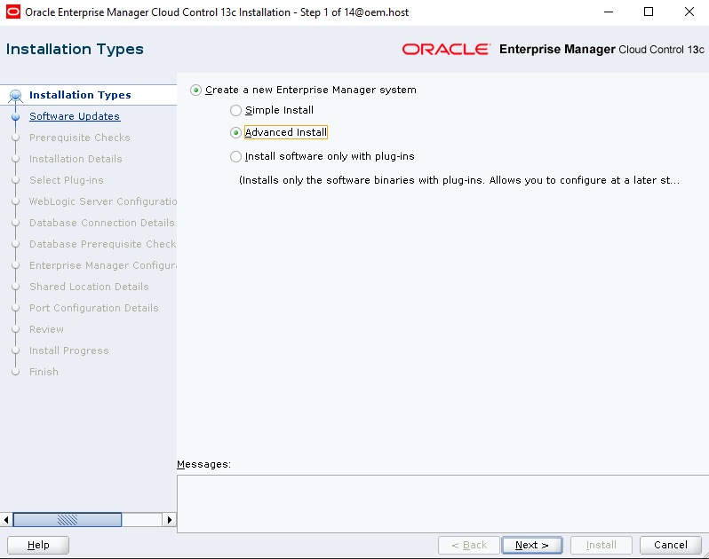

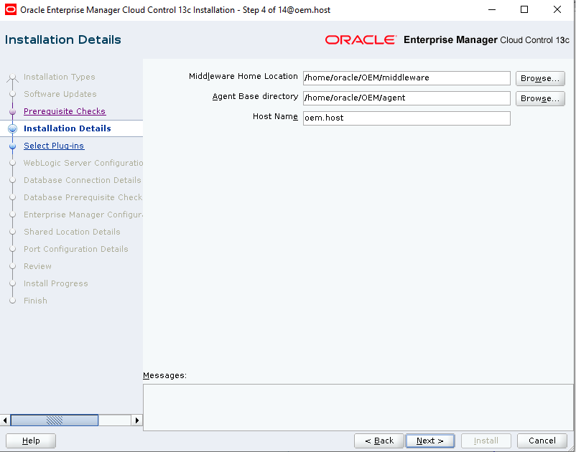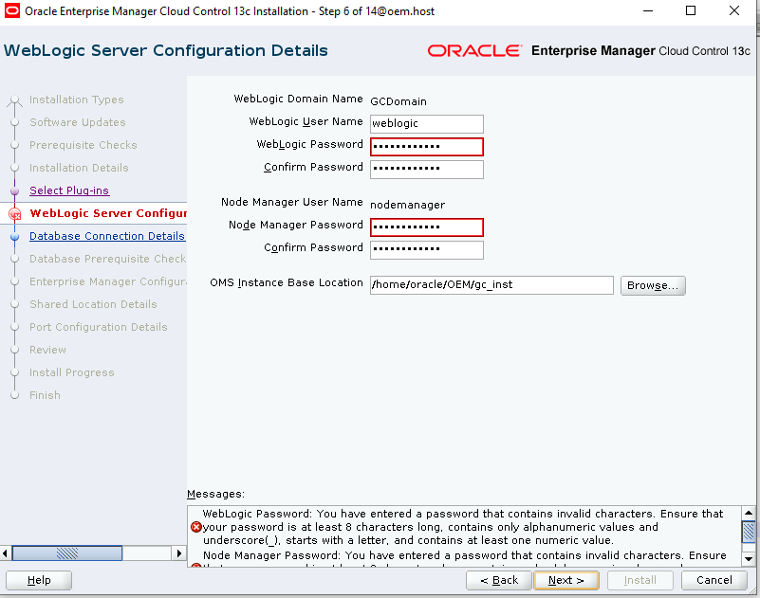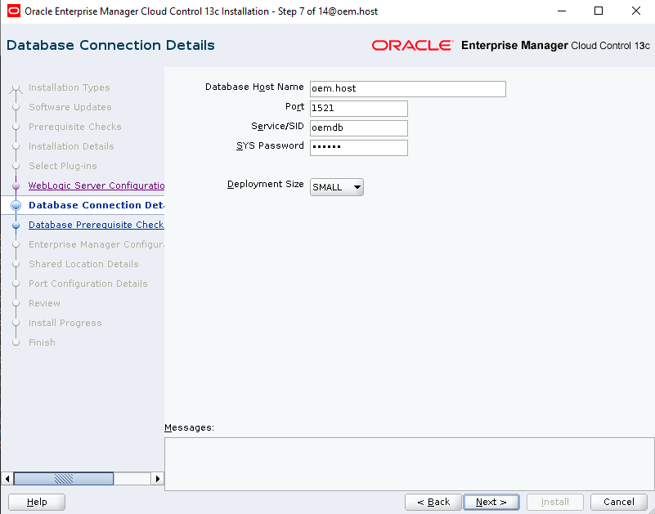

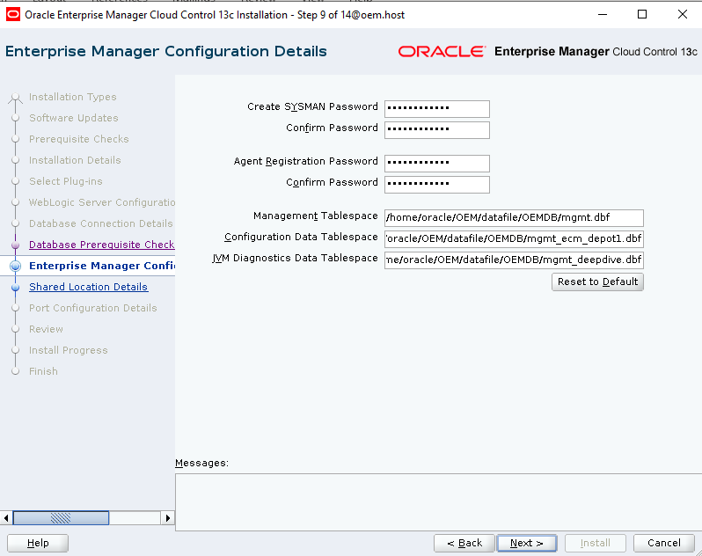

After the installation this provide the URL details. Use ip instead of hostname to open URL.

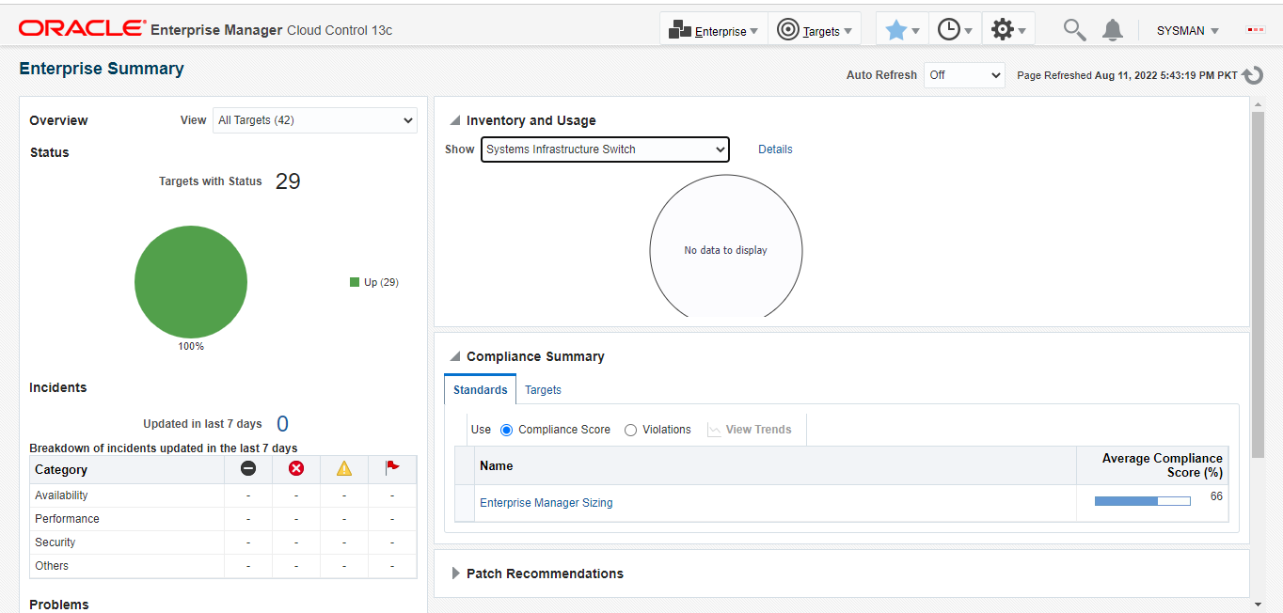

Starting and stopping EM services.

First go to following location:

/home/oracle/middleware/bin

To start OEM:

./emctl start oms

To stop:

./emctl stop oms

To Check status:

./emctl status oms



